Updated Guidelines on Appropriate Referral of Basal Cell Carcinomas

There is to be a revised local 2 week wait (2WW) dermatology referral form which reflects updated NICE guidelines on the management of basal cell cancers (BCCs). The form remains predominantly, for the urgent referral of suspected Melanoma and Squamous cell carcinomas.
The vast majority of basal cell carcinomas should still be referred ROUTINELY.
BCCs are very common and about 1 in 5 of us will develop one at some point in our lives. BCCs can be nodular (head and neck BCCs are predominately nodular), superficial (more common on the trunk as pink plaques), pigmented or morphoeic (usually central face waxy yellow/white patches with ill- defined edges and well defined telangiectasiae). They are slow growing, sometimes over several years, usually starting as a pinkish papule which eventually ulcerates. Rate of growth averages 0.5mm every 3 months. They almost never spread and are curable. Half affect the head and neck. 20% are pigmented and dermoscopy is especially helpful in making the correct diagnosis of these.
Excision of a BCC requires a 3-4mm margin and excision in areas such as around the eyes, nasolabial areas, close to the lip and on the pinna can be difficult especially if large, sometimes needing a more complex repair. If a lesion is picked up at 3-4mm it may require much less invasive surgery than one of 7-8mm.
The revised 2WW form has therefore been developed to reflect this. Any BCC in potentially problematic sites such as proximity to the eyelids, nose, pinna, external auditory canal or large size can be considered for referral on a 2WW form. BCCs around the eye may well then be referred on to occuloplastics at APH and other problematic lesions to maxillofacial surgery at APH as long as the diagnosis of BCC is certain.
There are huge pressures for 2 week appointments in the Dermatology department. The number of sessions dedicated to 2WW referrals is limited, so please try to make careful use of them to ensure that the department is not overloaded with non-urgent BCCs in particular. Many 2WW referrals turn out to be seborrhoeic keratoses and other benign lesions. There are excellent courses run by the Primary Care Dermatology Society in lesion recognition/ dermoscopy.
Here are some examples of BCCs which would be regarded as suitable for a 2WW referral.
We hope this is helpful.
Dr Judith Holley and Dr Boon Tan

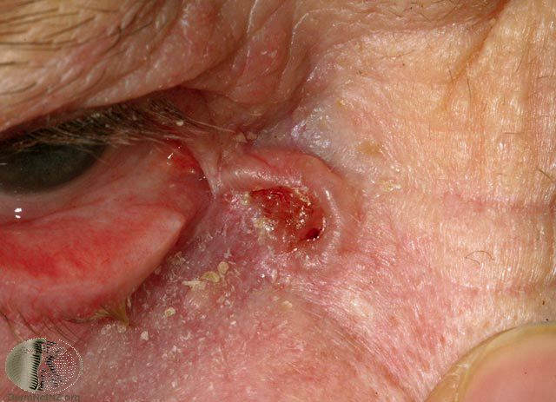

This ulcerated BCC is very near the inner canthus.

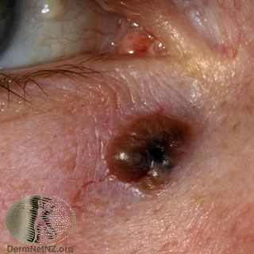
This pigmented BCC is close to the lower lid.
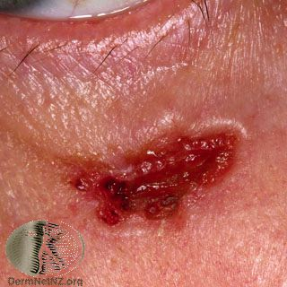
Another ulcerated BCC near the lower lid.
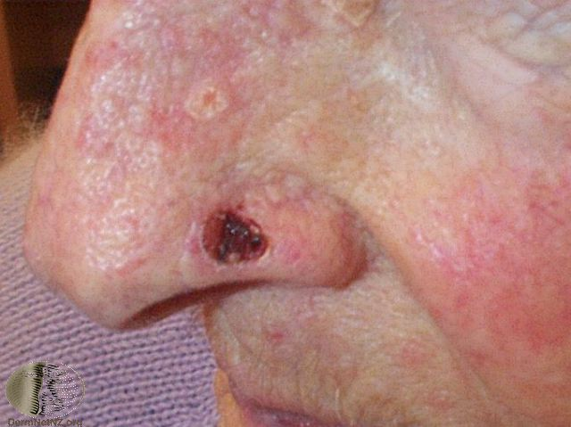
This ulcerated BCC is a fair size and near the alar rim where a repair could be difficult.

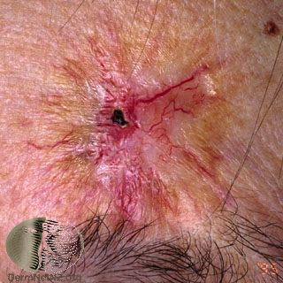
This is a large morphoeic BCC above the eye brow and 2WW referral could be considered due to its size.

