Growing our own: Developing Advanced Nurse Practitioners at Wirral
Linda Taylor, Outreach Services Librarian, Wirral University Teaching Hospital NHS Foundation Trust (WUTH)
The Library and Knowledge Service (LKS) has been supporting Trainee Advanced Nurse Practitioners (TANPs) for the last couple of years, to develop their evidence based practice and research skills, and to support their academic studies to master’s degree and beyond.

How did it start?
Gill Beasor, Implementing New Roles Facilitator (Advanced Practitioners), Resuscitation Officer/Clinical Facilitator (EWTR) approached the LKS to gain support for a cohort of TANPs.

What support was required and why?
The TANPS role was a new one and is intended to help fill the gap between doctors and nurses. Part of the reason this role was instigated related to European Working Time regulations and doctors working hours and a smaller numbers of junior doctors arriving. TANPs operate like Junior Doctors and rotate around the hospital divisions, so where these staff had previously been senior, experienced and a role model in their specialist area, they were suddenly operating in challenging new areas, in a new role which lacked definition. They were facing resentment from some consultants and doctors and also from their nursing colleagues. In addition, all of the TANPs had to successfully complete their Masters studies to remain in post and progress. The academic stakes were high and some had not studied for some time.

We began by offering customised “Finding the Evidence” and “Introduction to Critical Appraisal” sessions. The critical appraisal session was planned and facilitated by Linda and run around a journal article, selected by Gill, which examined the role of the ANP, including identifying barriers. Once these orientation and skills sessions had been completed our resolution was that the first Journal Club session should happen.
The first journal club session was facilitated by Linda and Gill chose an article and explained why it was relevant. The session was structured via a PowerPoint presentation which utilised the relevant CASP critical appraisal checklist. This provides a series of questions which can be posed about the specific article, including some screening questions which ensure that the article in questions is worth appraising! Research terms were defined and statistical and analytical approaches explored. The session went well, but participants were very concerned about who would have to present next and how to do it.
We sold the concept by arguing that individuals could bring along pieces of original research that they were using in their practice, evidence that related to areas of challenge in their new clinical areas etc. and/or their studies thereby gaining the benefit of having everyone’s opinion on it, rather than just their own.
Journal club has continued on a regular basis, with participants steadily gaining in understanding, experience and confidence. The sessions have been lively and thought provoking. Challenges have included finding articles of sufficient relevance to the whole group in terms of their work places, expertise and academic studies. As the TANPs neared their dissertation stage they became keener and keener to get feedback on key articles that they had used in their work and gain critiques on their own research methods.
After the first few journal club sessions we spent a little time on reflection (without Gill) focussing on what the group wanted from journal club and how they would like to see it develop. This guided planning and encouraged ownership and participation.
A second cohort of TANPs and a handful of others were recruited, received relevant training and also joined the journal club.
Those undertaking their dissertations received individualised research support and “critical friendship” from Linda.
Who from the Library and Knowledge Service has contributed?
EVERYONE. Although Linda has planned and delivered the sessions and journal club it has been as part of a much bigger endeavour. Everyone who has answered a query from a TANP, provided literature searching advice, sourced inter library loans, sent out evidence alerts or just been there to encourage them has contributed to their success. Because they had no “base” in the hospital and they felt supported in the library they often used the McArdle Library as their place to work, meet etc.

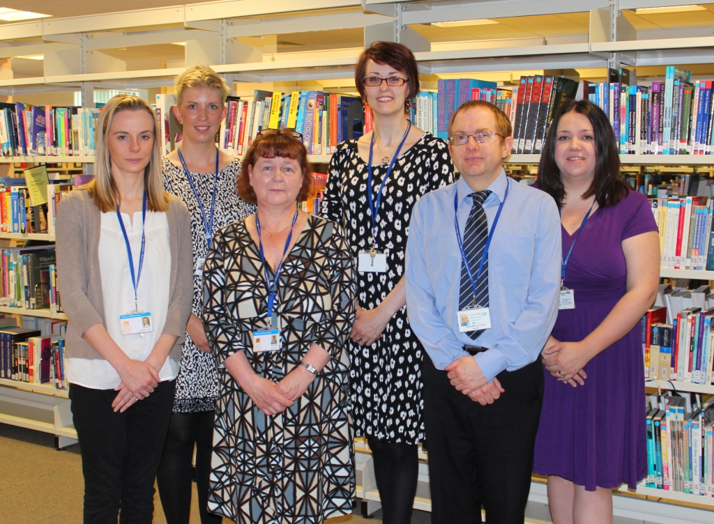
Annabel, Victoria, Linda, Jennifer, Graham and Beccy

Why is it important?
Gill Beasor sent an email which said “Can I just extend a big thank you to you and your team on behalf of the entire trainee ANP team. Your support with our journal clubs and supporting the trainees with library searches and sourcing journal articles has been invaluable. The impact has been great as it has helped them to achieve in their studies, given them confidence in literature searching, critical appraisal, provided evidence to support clinical decision making. Indeed at our regular meetings the trainees value your input greatly. Many thanks for your continuing support as it is greatly appreciated.”

What difference has it made?
TANPs have been supported in undertaking Masters dissertations in a number of key clinical areas including:
- Nurses knowledge of Sepsis and how the knowledge gaps can be filled by training interventions with consequent benefits to patients
- How to recognise and minimise Acute Kidney Injury in Patients undergoing Emergency Orthopaedic procedures
- How common co-morbidities affect the causes and patterns of hospital readmissions
- Staff attitudes towards witnessed resuscitation in the Emergency Department
- Does an increased mews score increase patients length of stay in hospital in patients with an exacerbation of COPD?
- Perceptions and attitudes about the role of the Advanced Nurse Practitioner
- Nurses’ reflections on discussing sexuality with patients: responsibilities, doubts, and fears
These research topics offer increased knowledge and understanding for Trust about key strategic areas such as patient’s survival, progress, clinical and psychological outcomes and experiences; family experiences; patient flow; Trust planning and finances; Staff performance and training and their impacts across the local health economy. The links to Trust and LKS objectives are clear notably:
WUTH Objective | LKS Objective: We will
Objective 1: To be the top NHS Hospital Trust in the North West for patient, customer and staff satisfaction | 1. enable the delivery of outstanding care by providing high quality, evidence-based services that clearly demonstrate value.  2. facilitate excellent patient care by embedding the best evidence into decision-making processes.  3. equip staff to deliver an outstanding patient experience by mobilising knowledge and diffusing best practice throughout the organisations served.
Objective 2: To lead on integrated, shared pathways of care with primary, social and community care | 5. adapt to an ever-changing environment by nurturing a highly knowledgeable, flexible LKS team with expertise in a wide range of areas.
Objective 3: To deliver consistently high quality secondary care services enhanced through the provision of regional specialist services | 6. underpin clinical decisions with the best evidence by providing a high quality literature searching service tailored to individual needs.  7. contribute to the research capacity of the organisations served by working in partnership with researchers and research departments.  8. enable high quality care by providing access to a comprehensive range of cost-effective and high quality information resources.
Objective 4: To ensure our people are aligned with our vision | 9. encourage staff engagement by providing a highly visible LKS that is easy and convenient to access regardless of time, location, or role.  10. contribute to staff satisfaction by offering personalised services, tailored to the specific needs of individuals or groups.
Objective 5: To maximise innovation and enabling technologies | 11. maximise the use of technologies by delivering mobile services that are digital by default.  12. contribute to innovation and share best practice by providing horizon scanning and current awareness services.
Objective 6: To build on partnering for value | 14. maximise financial performance through investment in resources and seeking opportunities for external funding.
Objective 7: Supported by financial, commercial, and operational excellence | Comment: Financial savings were identified and delivered via several of the research projects i.e. length of stay, readmissions,

How was it for them?
Two of the TANPs were brave enough to appear on film to share their experiences of using the Library Services and here are their words:
“I started at Arrowe Park eighteen months ago when I came over here to do a Masters, so I’d come from an outside Trust and moved over onto the Wirral, so when I got here I didn’t know anybody or anything or any of the systems, so the library’s had a lot to do with me finding my way around.
When we started our masters we had to get used to writing at level seven so, having the journal club for the advanced nurse practitioner trainees gives us a chance as a peer group to discuss level seven writing, how to critically appraise, so that’s been really, really important for us.
Certainly a lot of journals available, you know, for you to look up current practice, because all of a sudden you find yourself doing a masters and working at a more advanced level as a nurse so you need to have the evidence to back up you your, new way of working … your practice has changed all together.
So the journal s here and the electronic resources especially and even if a journal isn’t available then you can fill in an interlibrary loan form and they provide that very quickly and let you know when it’s here and that’s been brilliant.
E-bulletins that come out when you fill a form in and say that you’ve got a specific interest into and if anything comes new it can come out to you without you having to do literature search after literature search, it enables you to hone in to one specific area.
Our entire training is based on us qualifying and then carrying it on with CPD so we’ve got to prove, throughout, through our portfolio through learning, through literature searches that we’re continuing that process of being masters level.
That is just invaluable, really even being here til 2oclock in the morning by yourself and being able to take a book out overnight as well and return books especially, you still have to work, we still have to work clinical shifts.
The library “it’s just like a lifeline really to be honest, and everybody knows, and Linda especially, she was fantastic. They sort of keep you going, Jen, all of them really. Towards the final stages of doing your dissertation when you feel like you’re about to die.
They’ve been fantastic. In the last trust I’ve worked in I couldn’t have told you where all the clinical research and things was, whereas here it was sort of from day one until now and we’ve used that all the way along to try and get these masters finished.”
On a personal level one of the TANPs sent an email to Linda stating “if it wasn't for you, I think I would have quit”.
Where next?
The regular journal club continues. The balance between qualified and Trainee ANPs is changing which is bringing new opportunities and challenges. In addition, Linda has been approached by the Clinical Skills Facilitator for Medical Students and Assistant Practitioners, due to the perceived success of the work with Trainee Advanced Nurse Practitioners and Advanced Nurse Practitioners to present a similar proposition for supporting Trainee and Qualified Assistant Practitioners. The plan is to begin with some customised training i.e. “Finding the Evidence” and “Introduction to Critical Appraisal” and then move on to instigating and facilitating a journal club.

