Wirral End of Life Care Charter
Care, kindness and understanding

Why the Wirral End of Life Care Charter is important!

It is kind, humane and professional to reassure patients at the end of life stage, and their families and carers that they can expect to receive the highest standards of care from the health and social care providers – and also the other professional groups who serve people at this time.
There has been so much controversy in the past about end of life care. Wirral is seeking to put that firmly in the past, and, instead, look to a set of expectations that, although they cannot lessen grief, can help to give peace of mind about the quality of care available at this difficult stage.
The Charter, with its 12 points, was designed by Wirral’s health and social care professionals. It is supported by Wirral End of Life and Palliative Care Partnership Group, and Cheshire and Merseyside Palliative and End of Life Care Clinical Network Steering Group.
It is important that everyone involved with end of life care knows of the standards contained within the Charter, and commits to endeavouring to achieve them, so that Wirral residents have the peace of mind that they can rely on good, respectful and dignified end of life care.

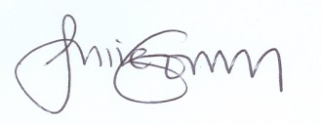
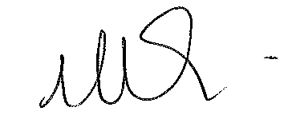

Dr Maria Earl Julie Gorry
NHS Wirral Clinical Commissioning Group Chief Executive,
Cancer & End of Life Partnership Lead Wirral Hospice St John’s

On behalf of Wirral Palliative and End of Life Care Partnership Group
Web: http://wirral.findmehelp.org.uk/
Twitter: https://twitter.com/WirralEoL

scan on to a smartphone
to access: Find Me Help Website
Web: http://wirral.findmehelp.org.uk/
Twitter: https://twitter.com/WirralEoL

scan on to a smartphone
to access: Find Me Help Website
Wirral End Of Life Care Charter
Care, kindness and understanding

HOW YOU CAN HELP

- Sign the Pledge.
The Pledge, signed by a senior member of your organisation, is intended for display in your place of work alongside the Charter statements, so all your colleagues are aware that your organisation is supporting the Charter and its aims.

- Make the Charter available to your colleagues and service users.
Explain to them what the Charter means to you, and how it sets the standard for the end of life care your patients or service users can expect.

- Sign the Supporters’ Roll.
You may wish the members of your service to sign this Supporters’ Roll in their own right, as this will indicate that individuals are aware of the Charter, and support it and its aims.

- Publish the Charter on your website, in your newsletter etc.
Please take active steps to inform your service users about the Charter.

- Spread the word!
The more people aware of the Charter and its aims, the better. Ideally, everyone on Wirral should know that the highest quality end of life care is available here, and is easily accessible.

WHAT ARE THE BENEFITS TO YOU?
You are publicly demonstrating your organisation’s commitment to the highest standards.
We encourage you to register your organisation’s details on the microsite ‘Find Me Help’, which will aid patients, families and their carers to access the end of life help and support they are seeking fast and efficiently.
Web: http://wirral.findmehelp.org.uk/
Twitter: https://twitter.com/WirralEoL

scan on to a smartphone
to access: Find Me Help Website

