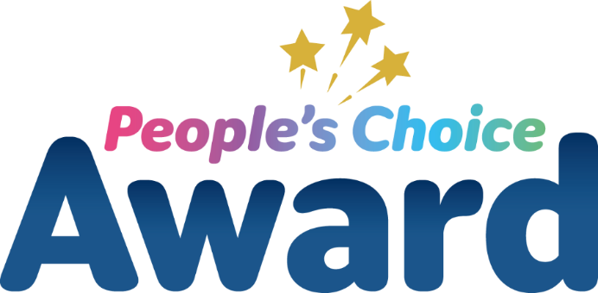
Nominations for the 2026 People’s Choice Award are now open!

We are proud to be holding a combined awards ceremony, for staff working at Wirral University Teaching Hospital and Wirral Community Health and Care NHS Foundation Trusts. This provides a special opportunity to recognise the hard work, commitment and services provided by staff members and teams across both organisations.

Each year we receive thousands of compliments from the people we care for, praising our teams and the quality of our services. We would like YOU to help recognise our amazing staff.

If you have received exceptional treatment and care from an individual or one of our teams, please tell us by nominating them for a People’s Choice Award.

Criteria: The team or individual will have:

- Delivered exceptional care, service or support
- Made a positive and lasting impression on patients or service users
- Demonstrated kindness, compassion and dedication
- Gone “above and beyond” expectations
How to nominate
Using this form, please tell us clearly, why the individual or team you are nominating, deserve this award. Please attach an additional sheet if required.

Please return your completed form to the Workforce Engagement and Inclusion Team, Education Centre, Arrowe Park Hospital, Upton, Wirral, CH49 5PE.

Closing date
You have until Wednesday 29 July 2026 to submit your nomination. Winners will be announced at the awards ceremony in November!

Thank you so much for taking the time to nominate a member of our staff!

Would you be happy to be contacted regarding your nomination? If so, please provide your full name and contact details:
Name: _____________________________ Contact number: ___________________________

Email address (if known): ________________________________________________________

Details
- Please tell us the name of the individual or team you would like to nominate:

- Please tell us the ward/department/service area (if known):

- Which Trust do they work for? Please tick one box:

- Wirral Community Health and Care NHS Foundation Trust

- Wirral University Teaching Hospital NHS Foundation Trust

- Both

- Unsure

Using the criteria overleaf, please tell us why you feel they meet the criteria and deserve to win the People’s Choice Award:

