­

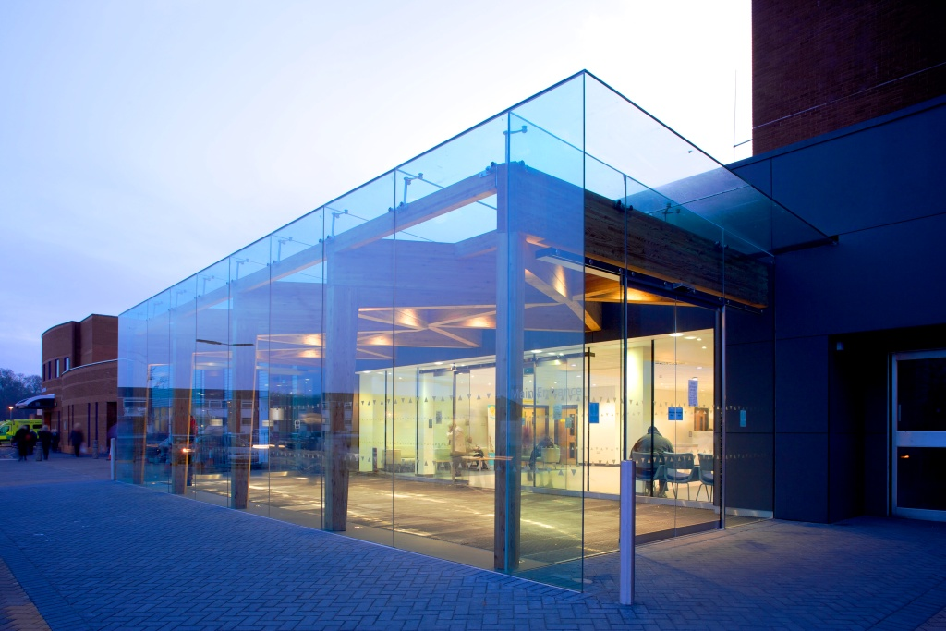­­­ **Introduction**

**Recruitment Briefing**

**[Position Title]**

­



Dear Candidate**,**

Thank you for your interest in Wirral University Teaching Hospital NHS Foundation Trust (WUTH) and this hugely important position of our new [Job Title of Vacancy].

This organisation is a major employer on the Wirral and we take our role as a partner in the wider health and care economy seriously. We recognise our opportunity and responsibility to improve the future well-being of our population. As an evolving and strengthening senior leadership team we are addressing performance challenges whilst developing a clear strategy to achieve our potential as an organisation and a system.

We are seeking a values-driven [Job Title of Vacancy] who can handle risk and ambiguity comfortably and can bring intellect and insight to leading complex services within the context of a wider health and social care economy.

Wirral really is an enjoyable place to live and to work. I hope you enjoy finding out more about WUTH and its local area of beautiful coastline, recreation and adventure inside this recruitment briefing. Should you wish to talk anything through, please do get in touch.

I look forward to meeting you during the process.

**Dr Nicola Stevenson**   
Executive Medical Director

**The local area**

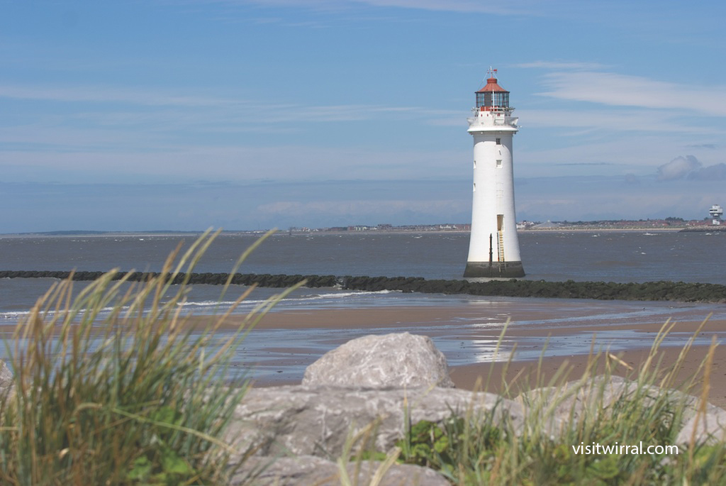

**Wirral has a stunning coastline and a beautiful countryside, making it a great place to live and work.**

It offers 50 miles of rural walking routes, cycle areas and beaches. In fact Wirral has two of Britain’s most famous rivers, the Mersey and the Dee, running along its Eastern and Western coastline.

Excellent housing is available in nearby suburbs and there are a variety of schools. The University of Liverpool, University of Chester and Liverpool John Moores University are also within easy travelling distance.

There is also quality food and drink, including Michelin Star dining and many tea rooms.

The area has an idyllic, serene, landscape and is a delightful location for those who like to unwind with a round of golf as it boasts 14 golf courses.

The cities of Liverpool, Chester and Manchester as well as North Wales are easy reach to and from Wirral with various transport links including motorway, train, bus or ferry. National parks, the Peak District and Lake District are also easily accessible.

There are also excellent transport links to Liverpool John Lennon Airport and Manchester Airport offering both budget and long-haul flights.

Wirral is also an area of rich history with many heritage buildings within its picturesque surroundings.

**About WUTH**

**Wirral University Teaching Hospital serves a population of 400,000. It is one of the biggest and busiest acute NHS trusts on the North West, employing more than 6,000 staff.**

Our aim is to deliver the highest quality care for every patient. As a teaching hospital we are renowned as a leader in the region for high quality education and training for a wide range of staff including doctors, nurses and other clinicians.

We are proud of our teaching hospital status and we work closely with the University of Liverpool, University of Chester and Liverpool John Moores University to ensure staff and services reflect the very best clinical practice available.

Our organisation is at the forefront of innovation and a centre of excellence for digital technology. As a Global Digital Exemplar (GDE) we are one of the most digitally enable hospitals in the country, using technology to enhance patient care.

We are one of only 12 NHS acute trusts to achieve the GDE status to develop our digital technology, we call this Digital Wirral.

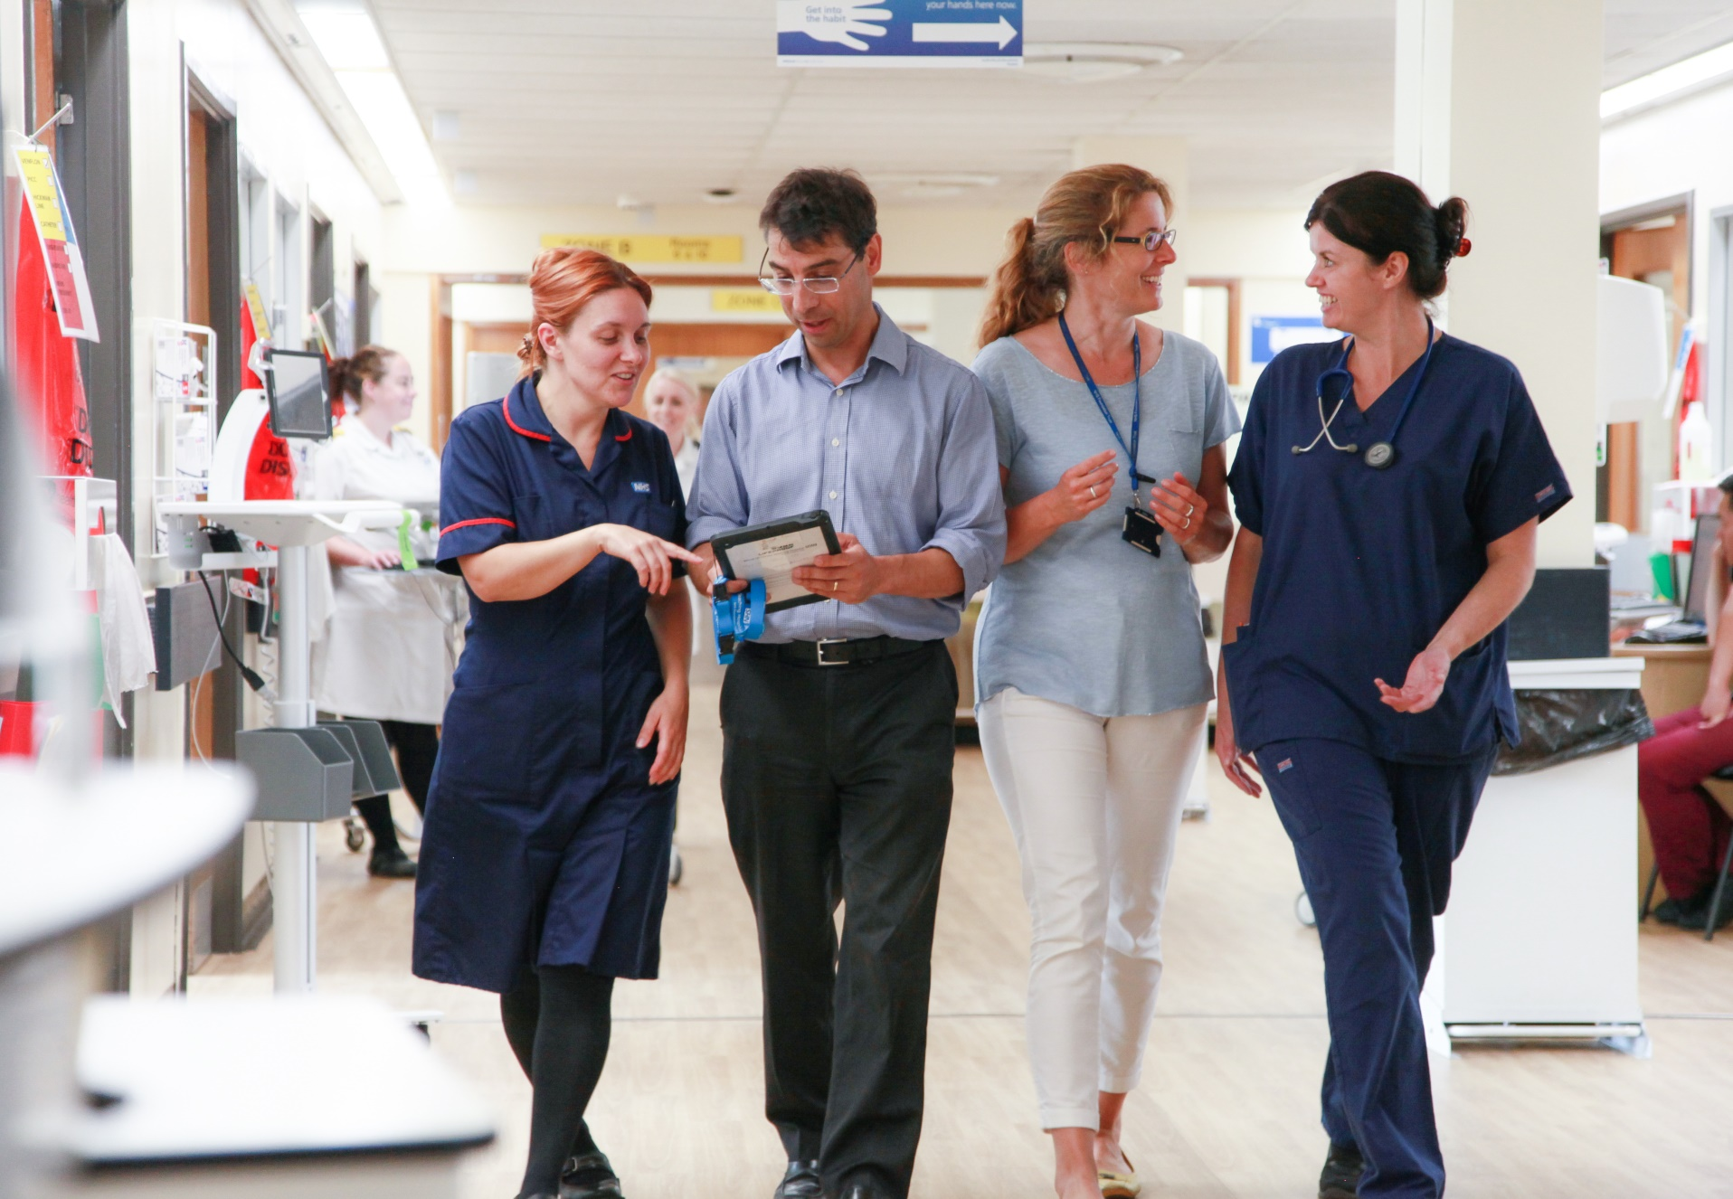

**Our WUTH future**

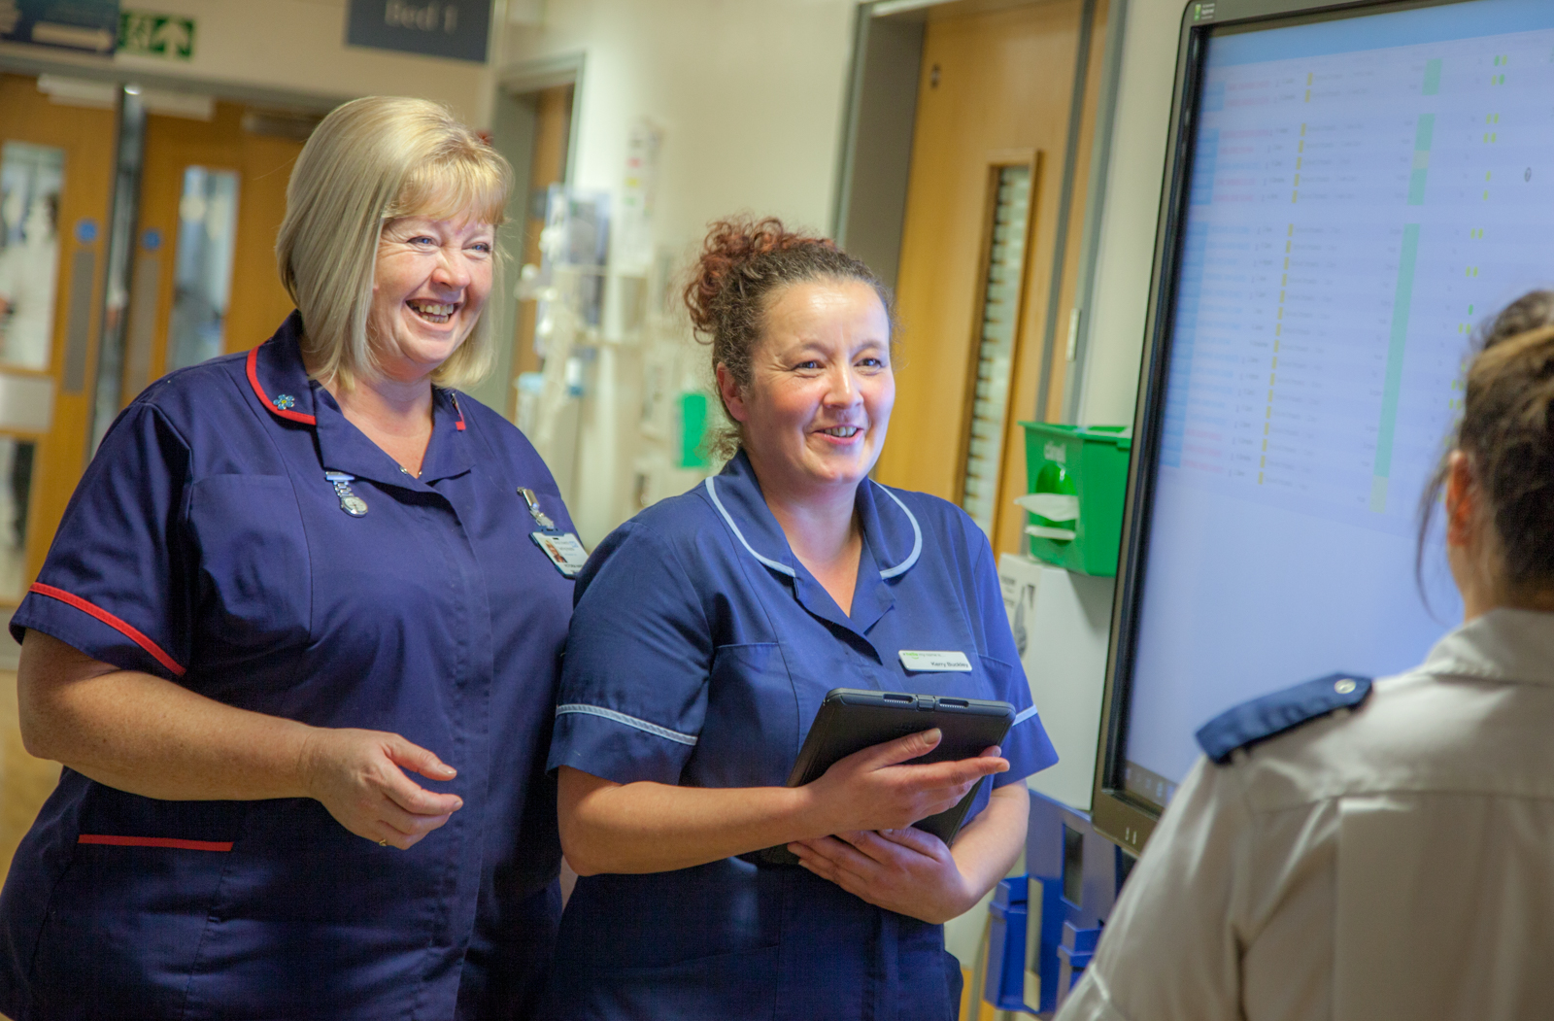

**As Wirral’s largest employer, WUTH is the thriving heart of the local community. Comprising Wirral’s only Emergency Department, it is one of the biggest and busiest acute NHS trusts in the North West.**

We want to make WUTH a truly great place to both receive care and work and the refresh of our vision and values is a fundamental part of this.

Recent months have seen a period of significant change and challenge, for us as an organisation and across the system and wider NHS.

Despite all of this, colleagues have carried on with great professionalism and have continued to provide good compassionate care to our patients. This has all taken place through what has been one of the hardest winters we have known.

We are well on with our journey of improvement and making a clear commitment to engaging with and investing in the whole of our workforce to support them to lead and improve their services.

There has been a focus on our future road map and what our improvement journey needs to looks like.

WUTH is a great place and we need to be recognised as an organisation that has quality improvement and supporting all staff to deliver the very best care at its heart.

One of the key steps in moving successfully is to ‘bring to life’ our organisational vision and values. We’re currently in the process of updating these, and something we would like you to be a part of.

**The opportunity**

|  |  |
| --- | --- |
| **Job Title** |  |
| **Division** |  |
| **Reporting To** |  |

*The Trust is committed to safeguarding and promoting the welfare of all unborn babies, children and adults and is signed up to both Wirral Safeguarding Children’s partnership Board and the Merseyside Safeguarding Adults Board policies and procedures. All Trust staff must be familiar with, and adhere to, these procedures. It is the post-holder's responsibility to attend the Trust’s mandatory Safeguarding Protecting Vulnerable People training, and to follow the relevant Trust's Policies and Practice Guidance.*