How to Change Your Email Signature
Hello My Name Is

Template:

Name Here
Pronounced: (Phonetic spelling here)
Pronouns: This is voluntary to include
Project Support Officer
Direct dial: 0151 604 7367
Internal extension: 8019

Step 1: Open a New Email in Outlook
Start by opening Microsoft Outlook.

Step 2: Access the Signature Settings
In the top toolbar, find and click on "Signature."

Step 3: Create a New Signature
A window will pop up; click on "Signatures..." in the dropdown menu.
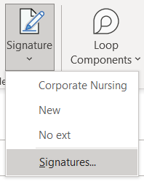

Step 4: Name Your New Signature
In the new window, click "New" to create a new email signature.

Give your signature a name. You can call it "Hello my name is" or any name you prefer.
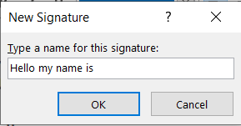
Press "OK" when you're done.

Step 5: Customise Your Signature
Now, you need to add the details to your signature:
Copy and paste the email template into the empty box. (You will need to use the Ctrl+C and Ctrl+V to copy and paste, if you aren’t sure how to do this, please scroll to the last page for instructions).
If there's an image with a hyperlink (like #Hello my name is), make sure to copy that separately.
Add your name, its phonetic spelling (if desired), and your pronouns (if you want to include them, like She/Her, He/Him, They/Them).
After making these changes, click "Save."
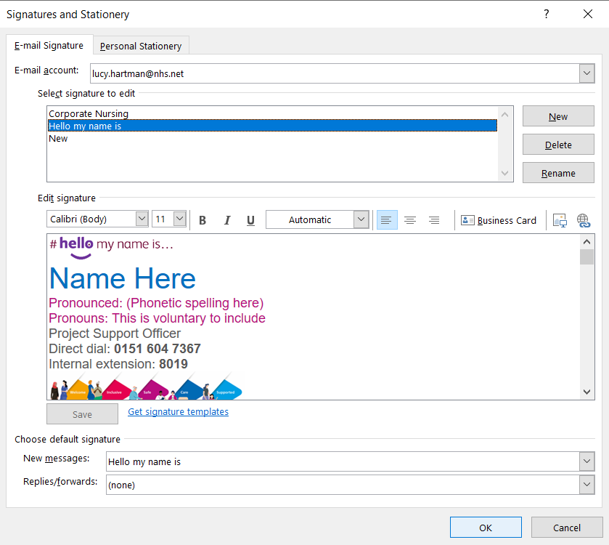

Step 6: Set Your New Signature
In the "New messages" dropdown menu, select the signature you just created ("Hello my name is").
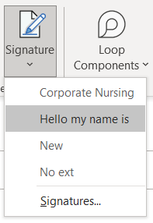

Step 7: Confirm Your Selection
Click "OK" to confirm your choice.

Step 8: Use Your New Signature
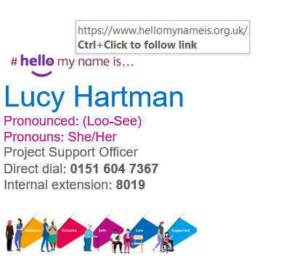
Now, whenever you compose a new email, your new signature will automatically appear at the bottom of your email.

How to copy and paste using your keyboard
Ctrl+C stands for "Copy" and Ctrl+V stands for "Paste."

Copying with Ctrl+C:
Find the Text or Item You Want to Copy: Start by locating the text, image, or file you want to copy. It could be in a document, a webpage, or even on your desktop.
Select the Text or Item: To copy text, click your mouse at the beginning of the text you want to copy, hold down the left mouse button, and drag your cursor over the text until it's all highlighted (usually turns blue). If you want to copy a file or image, just click on it to select it.
Press Ctrl+C: On your keyboard, you'll see a key labelled "Ctrl" or "Control." While holding down the "Ctrl" key, press the letter "C" at the same time. This action tells the computer to copy the selected text or item.
Pasting with Ctrl+V:
Open the Destination: Go to the place where you want to paste the copied text or item. It could be in a document, an email, a chat message, or another location where you can type or insert content.
Position the Cursor: Click your mouse where you want the copied text or item to appear. This is where you'll paste it.
Press Ctrl+V: Like before, hold down the "Ctrl" key and press the letter "V" at the same time. This action tells the computer to paste the copied content at the cursor's location.

