Helpsheet 20
ProQuest User Guide
Contents
A: Accessing ProQuest Databases and Creating a Personal Account 1
B: Searching for Terms 4
C: Searching for Subject Headings 7
D: Combining Search Terms and Subject Headings 9
E: Filtering and Saving Results 11

A: Accessing ProQuest Databases and Creating a Personal Account
1. Accessing ProQuest Databases
- Go to the Library Website For Library and Knowledge Services | Wirral University Hospital NHS Foundation Trust (wuth.nhs.uk)

- Using the gateway to the Knowledge Hub select ‘Search’
- Click on the yellow bar at the top of the page at sign in with your OpenAthens username and password
- Under the heading ‘In-depth searching’ select the database you wish to search e.g. British Nursing Index (BNI) or PsycInfo Index.

This will take you directly to the ProQuest page for the database you selected. However you can easily use on of the other databases by selecting ‘Change Databases’
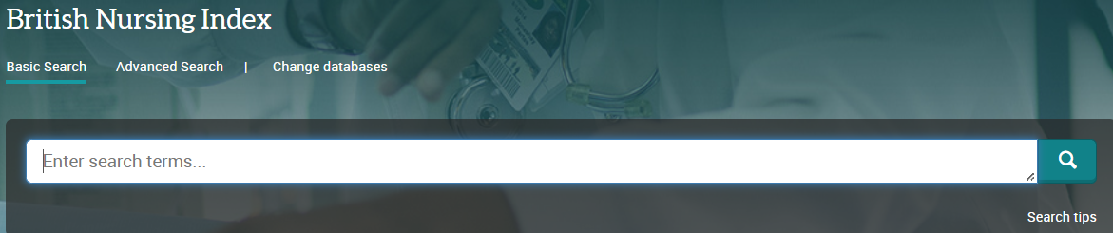

2. Select the database you want to search, for instance PsycINFO. Then click ‘Use selected databases’. We recommend searching one database at a time:
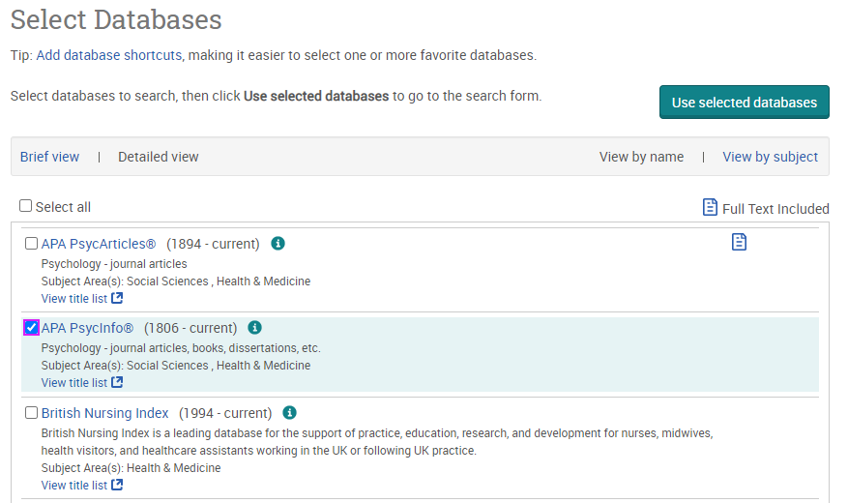
3. Once you have selected a database, you can begin searching. However, you will first need to create a personal/research account to save your searches and results. If you already have a personal account, login to it now.
Click on the person icon in the top right corner:

4. From here, either sign into your existing Research Account, or select ‘Create My Research Account’:

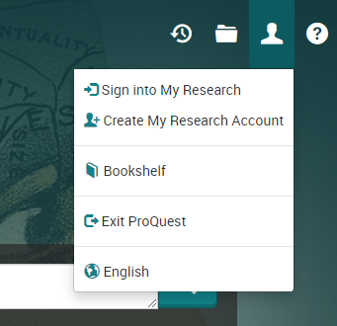

B: Searching for Terms
To get back to the ProQuest front page, click on the ProQuest icon on the top left:

5. To start a search, click on ‘Advanced Search’:

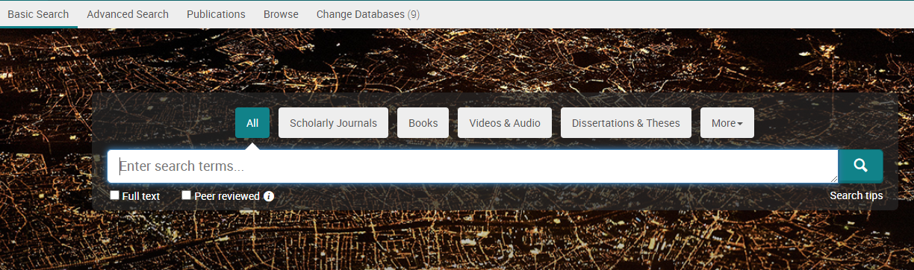

You can now start entering your search terms in the fields:

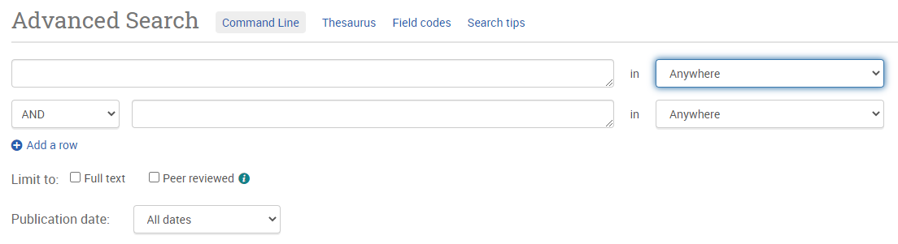

6. To select which fields you would like to search, use the drop-down menus. You can choose to search anywhere in an item’s record, or narrow your search down to specific fields:
7. If you want to search more than one specific field, for example, Title and Abstract, you need to search for these on separate rows using ‘OR’. Once you’ve entered your search term, select ‘Search’:

8. This will take you to the results page. To see your current search, click on ‘Recent Searches’ or the clock icon:
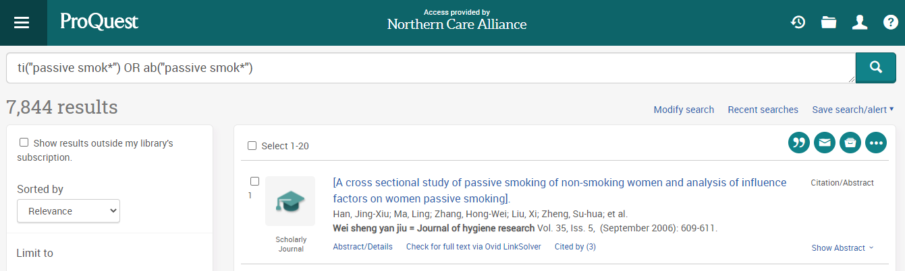

9. This will show you your search strategy so far.
To search further, you will need to get back to the Advanced Search by clicking on the three lines on the top left-hand corner:

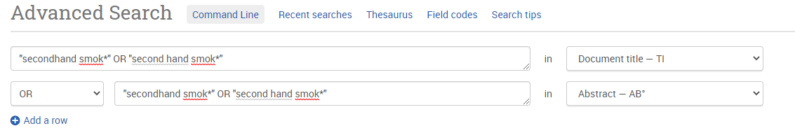

Repeat steps 7-9 for all keywords.

C: Searching for Subject Headings
10. To search for Subject Headings, select Thesaurus from the menu bar. Make sure to clear the search fields of previous keyword searches:

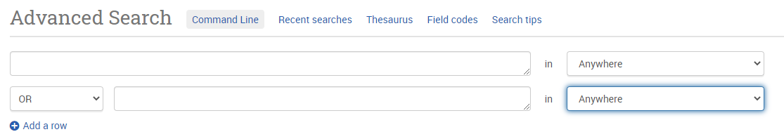
11. Type in what subject headings you want to search for and click ‘Find’:
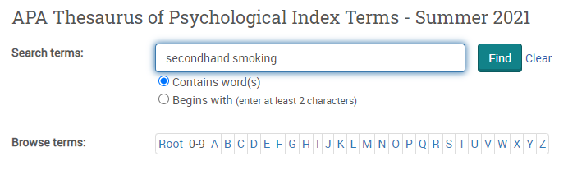

12. The Thesaurus may have exactly what you’re looking for, or offer suggestions to other subjects – have a go at searching for alternative terms too. Click on the relevant heading if there is one:
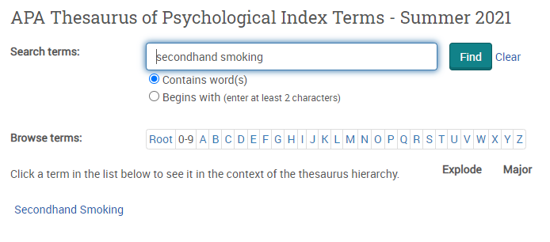

13. Tick the term(s) you want to use and click on ‘Add to search’. The Thesaurus will suggest broader and narrower terms, which you can also select, or click on the notes icon to find out more about each term:

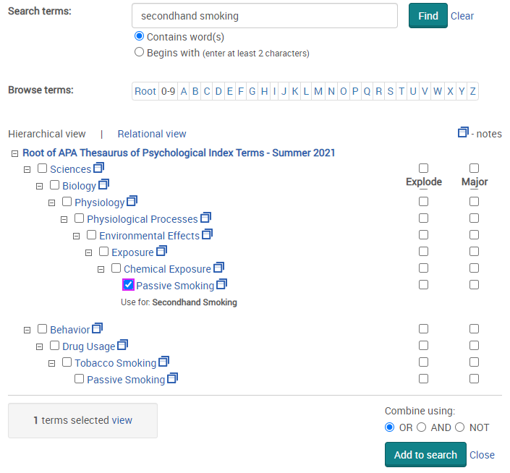

14. This will add the subject heading to the search field. Click ‘Search’ to search for the subject heading:

Repeat steps 11-15 for all subject headings.

Head back to your Recent Searches (by clicking the clock icon – see Step 9) to combine your search terms.

D: Combining Search Terms and Subject Headings
16. Combine your terms and subject headings by typing OR between the line numbers you want to combine (without the preceding ‘S’) E.g., 1 OR 2 OR 3
Then click ‘Search’:

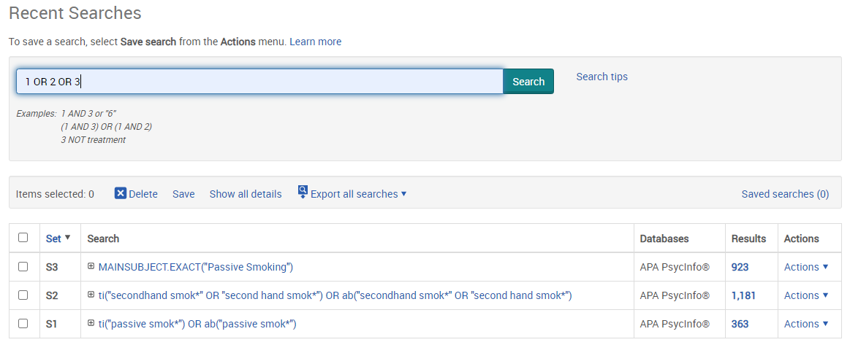

Head back to ‘Recent Searches’ (or click the clock icon) to view your strategy so far, including the results for the first concept (Line 4 in the example below):

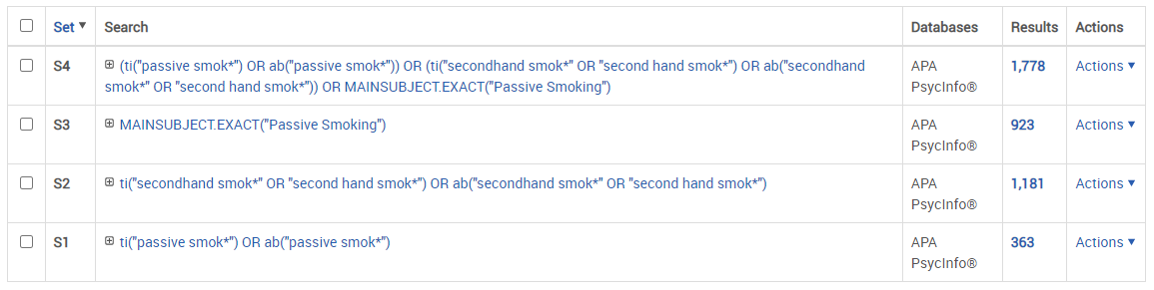

Repeat steps 7-16 to search for the rest of your concepts.

17. Once you have searched all your concepts, combine them using ‘AND’ and click ‘Search’. In the below example, line 4 combines the results for one concept (passive smoking) and line 9 for the second concept (cancer):

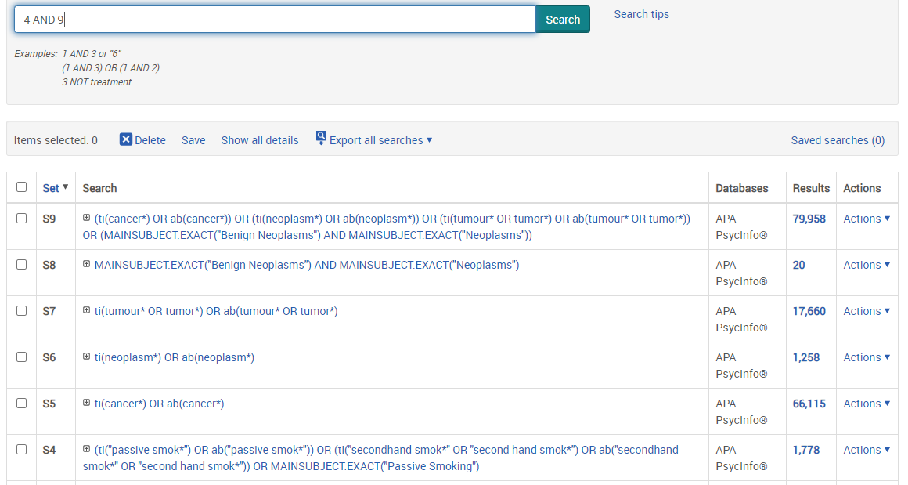

E: Filtering and Saving Results

18. On the results page, you can filter down your results by publication date, language, gender etc. on the left-hand side options bar:

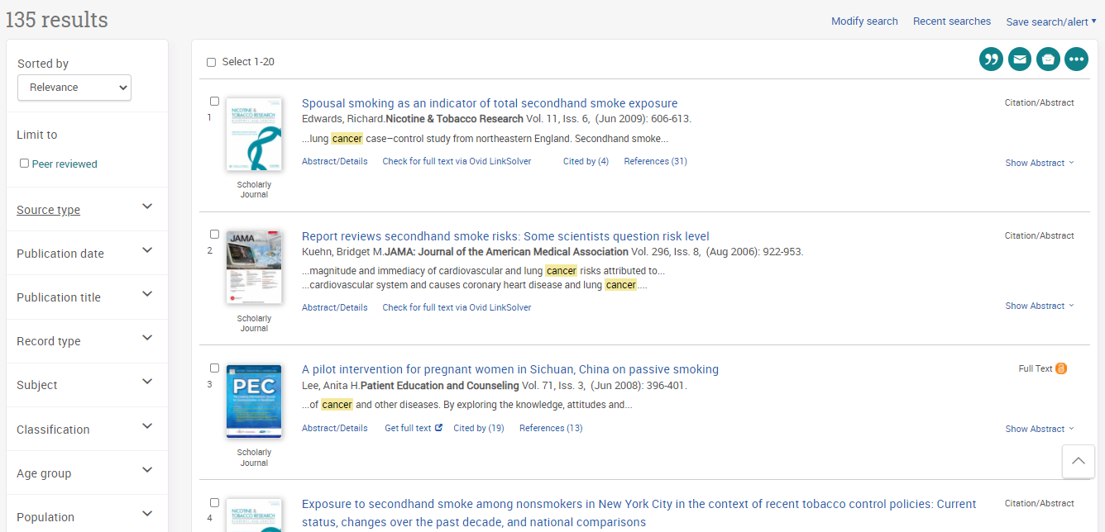

19. You can save individual results by ticking their selection box and clicking the ‘Save to My Research’ icon. These results will now be saved in your ‘My Research’ folder:

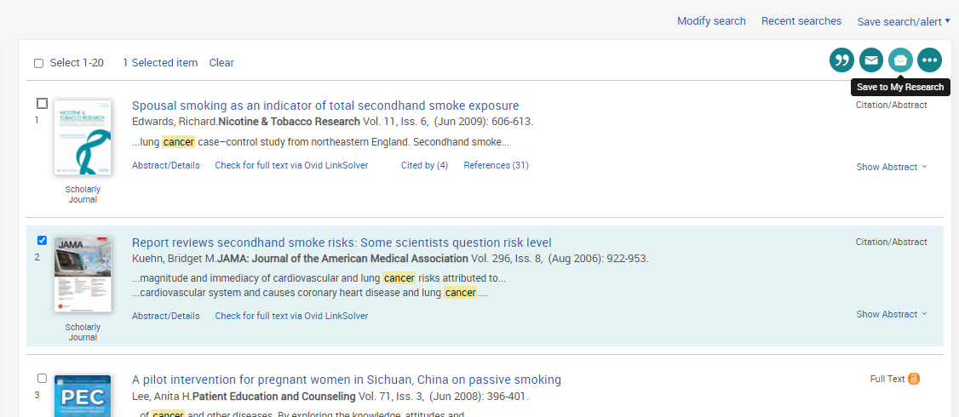

20. To export results, select the results you would like to export and click on the 3 dots to view all save options.

From here you can save your results in your Research Folder, send them via email, export to reference management software or save them as PDF:

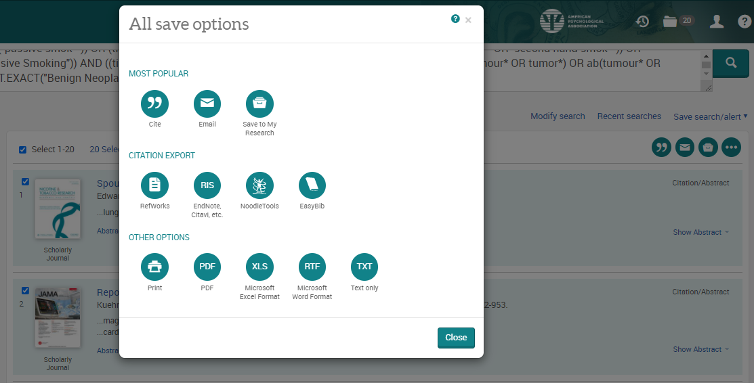

21. As well as saving the results, we highly recommend saving your search. To view your search, head back to your Recent Searches by clicking the clock icon:

22. Select the search lines and click ‘Save’:
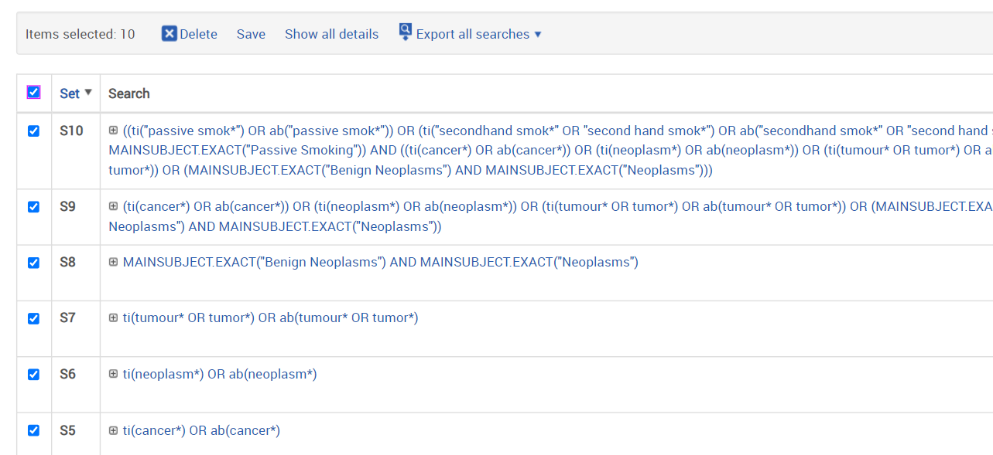

23. Give your search strategy a name and add comments if you wish.
Click ‘Save’:

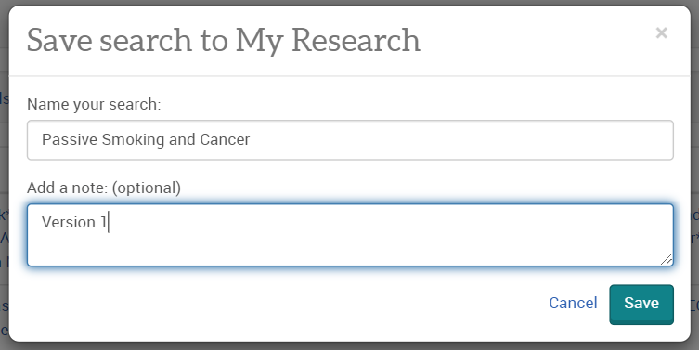

24. You can access your saved searches and saved results from your account menu:

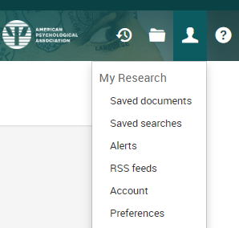

More questions? Book onto a training session with one of our experts:

